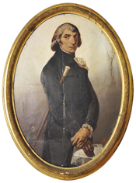
Liceo Classico “Giuseppe Parini”

Anno Scolastico 2019-2020

PIANO DI LAVORO ANNUALE

Docente
Materia
Classe

Livello iniziale della classe
________________________________________________________________________________

________________________________________________________________________________

Obiettivi di apprendimento
________________________________________________________________________________
________________________________________________________________________________

Contenuti principali del programma dell’anno
________________________________________________________________________________
________________________________________________________________________________

Strumenti (testi in adozione, appunti, sussidi audio-video…)
________________________________________________________________________________
________________________________________________________________________________

Metodi (lezione frontale, didattica laboratoriale, attività di gruppo…)
________________________________________________________________________________
________________________________________________________________________________

Verifica e valutazione
________________________________________________________________________________
________________________________________________________________________________

Milano, ___________ Il docente _______________________________

